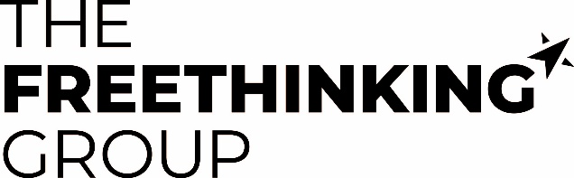

Carbon Reduction Plan
March 2026 (FY 2024-25)
Commitment to achieving Net Zero
The Freethinking Group Ltd is committed to achieving Net Zero emissions by 2050 at the latest.
Baseline Emissions Footprint
Baseline emissions are a record of the greenhouse gases that have been produced in the past and were produced prior to the introduction of any strategies to reduce emissions. Baseline emissions are the reference point against which emissions reduction can be measured.
Baseline reporting year emissions - 01 April 2021-31 March 2022:
Emissions | Total tCO2e
Scope 1 | 0.0
Scope 2 | 19.6
Scope 3 (Homeworker heating/air con/electricity, staff commuting, in-work travel, hotels, postage & couriers, telecoms) | 40.0
Total Emissions | 59.6

Additional details relating to the Baseline reporting year emissions calculations:
Our reporting year emissions inventory includes all our measurable scope 1 and 2 emissions, together with at least 67% of our total scope 3 value chain emissions.
Low office occupancy and the reduced need for travel caused by COVID-19 during 01 April 2021 - 31 March 2022 will impact on the baseline position, however we remain confident that current and future projects will enable us to achieve our net zero target in advance of 2050.
Current reporting year emissions - 01 April 2024-31 March 2025:
Emissions | Total tCO2e
Scope 1 | 0.0
Scope 2 | 0.0
Scope 3 (Homeworker heating/air con/electricity, staff commuting, in-work travel, hotels, postage & couriers, telecoms) | 61.2
Total Emissions | 61.2

Emissions Reduction Targets
To continue our progress to achieving Net Zero, we have adopted the following carbon reduction targets.
We project that carbon emissions will decrease over the next five years to 43.2 tCO2e by FY2029-30. This is a reduction of 24.0%, which will require an element of carbon offsetting.

Carbon Reduction Projects
Completed Carbon Reduction Initiatives
The following environmental management measures and projects have been completed or implemented since the beginning of the baseline period:
- Our Environmental Management system has been certified to the ISO14001 standard in June 22. We maintained this accreditation following audits in 2023, 2024 and 2025.
- Electricity for both offices has been moved to a green energy tariff.
- Creation of a Sustainability Board to stay abreast of best practice and innovation, communicating this to the rest of the business.
- All members of the Sustainability Board have sat and passed the Institute of Practitioners in Advertising’s (IPA) ‘Ad Net Zero Essentials’ training.
- Flexible working is encouraged with all staff able to work 2 days a week from home reducing levels of commuting.
- Employees are encouraged to use video conferencing where possible rather than travelling to meetings.
- Introduction of the ‘Workplace Bikes’ Cycle to Work scheme to encourage sustainable methods of commuting for employees.
- The sustainability team have developed an internal comms programme to build awareness amongst workforce of our journey to net zero.

Future Carbon Reduction Initiatives
We are exploring and planning to implement the following measures to continue to drive down future emission levels:
- We will continue to reduce business travel by air, rail, and road through effective measurement and a sustainable travel policy.
- Flights as part of business travel require Board member approval and should only be taken when necessary.
- Introduction of CO2 calculations on key client media plans – to highlight levels of CO2 produced as a direct consequence of a campaign, but also how clients can offset this.
- Community environmental initiatives including a Beach and or Canal clean.
- Review and evolve the EMS system to strive for continuous improvement and maintain the ISO14001 certification through annual audit.
- We are exploring initiatives to support employees switch to electric vehicles.
- We are considering options to provide employee incentives for switching to a green energy supplier.
Declaration and Sign Off
This Carbon Reduction Plan has been completed in accordance with PPN 06/21 and associated guidance and reporting standard for Carbon Reduction Plans.
Emissions have been reported and recorded in accordance with the published reporting standard for Carbon Reduction Plans and the GHG Reporting Protocol corporate standard and uses the appropriate Government emission conversion factors for greenhouse gas company reporting.
Scope 1 and Scope 2 emissions have been reported in accordance with SECR requirements, and the required subset of Scope 3 emissions have been reported in accordance with the published reporting standard for Carbon Reduction Plans and the Corporate Value Chain (Scope 3) Standard.
This Carbon Reduction Plan has been reviewed and signed off by the board of directors (or equivalent management body).

Signed on behalf of the Supplier:
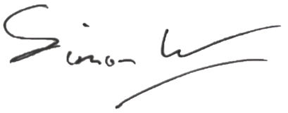

Simon Watson, Operations Director
Date: 10th March 2025

